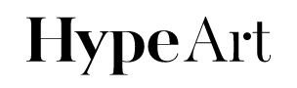

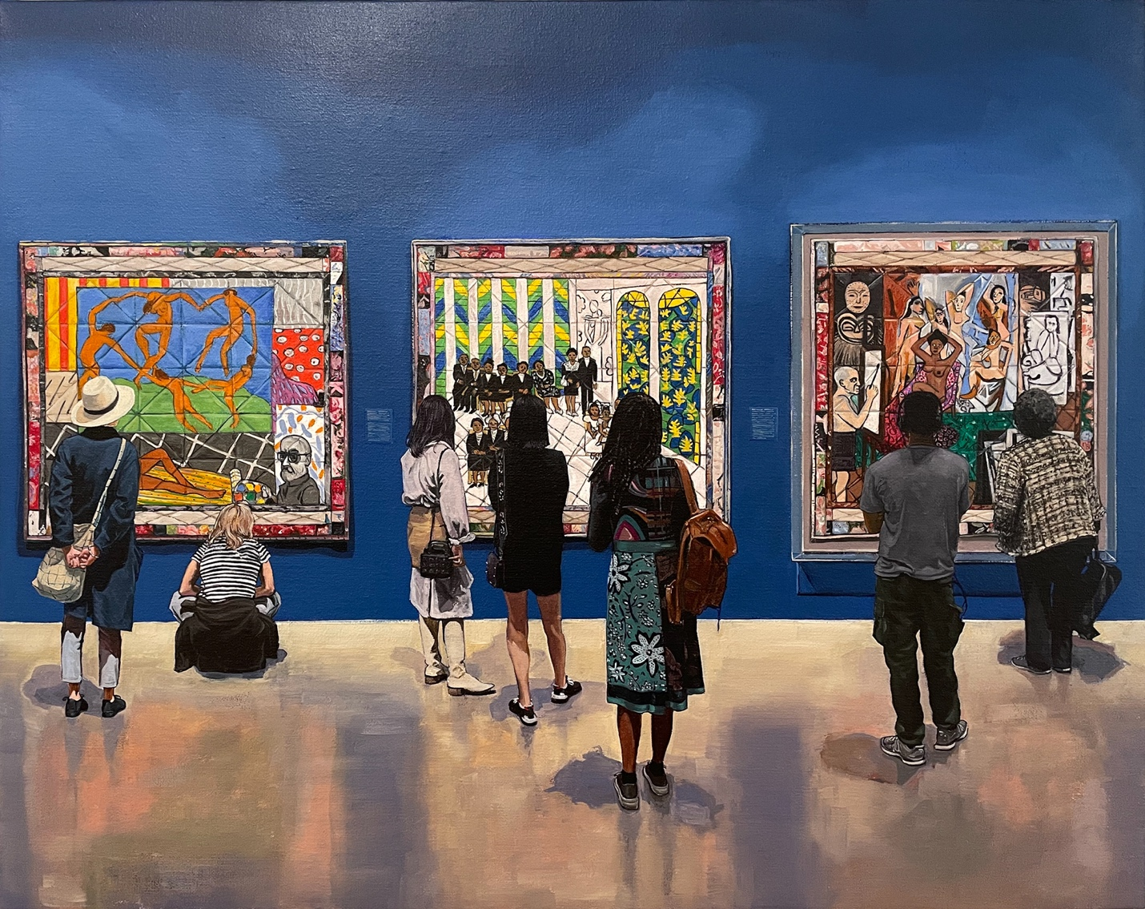

The 2022 ADAA Art Show Is Back at New York’s Park Avenue Armory
This year’s edition boats the most exhibitors in the fair’s history.

The Art Dealers Association of America’s (ADAA) annual The Art Show is back in full swing. This year’s edition boasts 78 different exhibitors, including 55 solo exhibitions from around the world – the most in the fair’s history.
Now in its 34th edition, The Art Show may not come with the spectacle that is offered at larger events, such as Art Basel or Frieze, but it still remains a great place to witness art and leave inspired.
Amongst the list of exhibitors at the 2022 edition, Cristin Tierney Gallery will present multilayered compositions from Joe Fig’s The Contemplation Series. Additionally, James Fuentes and curator Hilton Als will showcase paintings by the late Trinidadian actor and artist, Geoffrey Holder — which the gallery is currently featuring a new exhibition in full at its New York flagship until December 18.
Run-of-Show tickets to the fair cost $100 USD, while single-day passes are $30 USD. As always, full proceeds will benefit the Henry Street Settlement — which over the course of their three-decade partnership, has produced over $35m USD for 50,000 New Yorkers who come to the non-profit organization in need of employment, shelter and more. ADAA: The Art Show 2022 will be open until 5pm ET on November 6.
Elsewhere in art, Antwaun Sargent has curated a new group exhibition at Saatchi Gallery in London.
The Art Show
Park Avenue at 67th Street
New York, NY 10065

